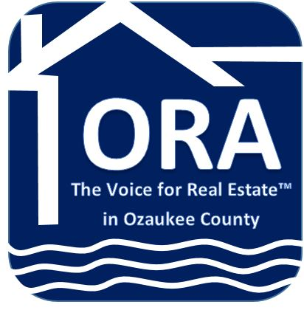

NEWS RELEASE

For Immediate Release
April 26, 2017

For More Information:
Call Tina Dorward
262-375-4730
picture included

DORWARD RECEIVES RCE DESIGNATION FROM
NATIONAL ASSOCIATION OF REALTORS®

(Cedarburg, WI) -- Tina Dorward, Association Executive of Ozaukee REALTORS® Association, is being honored by the NATIONAL ASSOCIATION OF REALTORS® with the REALTOR® association Certified Executive (RCE) designation, which recognizes exceptional efforts made by REALTOR® association executives.

Dorward is one of over 450 REALTOR® association executives who have achieved this mark of excellence. Local and state association executives who hold the RCE designation represent REALTORS® in 49 states/territories.

“I am very proud to receive this designation as it is an honor to be among such an elite group of Realtor association executives,” said Dorward who worked over two years receiving the education and points before she could sit for the exam. “It is definitely a high point in my career as an association executive, and I look forward to bringing the benefits of this education to my members.”

Prior to becoming a candidate for the RCE designation, applicants must document their association management and academic experiences. Once they have completed this first step, eligible candidates must successfully complete a multiple choice exam, which is based on a comprehensive understanding of association operations and management practices. Candidates must demonstrate knowledge of areas critical to REALTOR® association management, including association law, governance and issues related to member services. To retain the designation, RCEs must be recertified every four years.

Dorward will receive an award plaque from representatives of the Wisconsin REALTORS® Association during an upcoming event.

The National Association of REALTORS® is America's largest trade association, representing 1.2 million members, including NAR's institutes, societies, and councils, involved in all aspects of the residential and commercial real estate industries.

###

