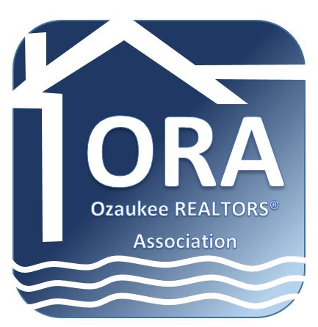

NEWS RELEASE

For Immediate Release
May 6, 2016

For More Information:
Call Tina Dorward
262-375-4730

Ozaukee County April Home Sales Increase Dramatically

Cedarburg, WI—Data market and sales information for Ozaukee County shows the number of single-family, condominium and townhome properties that closed in April totaled 106, compared to 77 for last month, an increase of 37.6 percent. That number is similar to April sales in 2015. The average listing price also increased significantly to $437K up $20K from March 2016 and up $50K compared to the same month last year.

The average number of days on the market was less than 90 for several cities within Ozaukee County, including Saukville, Cedarburg, Mequon, Thiensville, and Grafton. With the increase in sales, the number of available housing is at a premium.

“The increase in sales is typical for this time of year,” according to Mike Didier, 2015/2016 president of Ozaukee REALTORS® Association. “With the limited inventory, REALTORS® are having multiple offers on homes which can be stressful for all involved. It makes for a crazy market and time of year. We hope to see an increase in availability soon.”
The Ozaukee REALTORS® Association is headquartered in Cedarburg, Wisconsin. The mission of the Ozaukee REALTORS® Association is to serve its members by promoting professional and ethical conduct, to foster a spirit of cooperation among its members, to provide services and programs that assist its members in the successful conduct of their business, and to help defend the rights of all people to own and transfer real property.
REALTOR® is a registered collective membership mark which identifies real estate professionals who are members of the NATIONAL ASSOCIATION OF REALTORS® and subscribe to its strict Code of Ethics.





